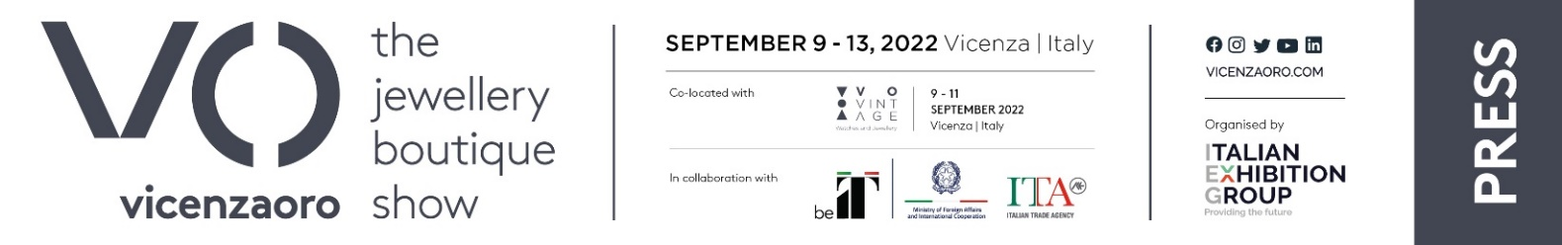
press release no. 1

VICENZAORO SEPTEMBER:
THE INDUSTRY’S MOST AWAITED EUROPEAN EVENT WILL BE BACK FROM 9 TO 13 SEPTEMBER,
IEG’S INTERNATIONAL JEWELLERY BUSINESS PLATFORM

- In Vicenza, at Italian Exhibition Group’s Expo Centre, the September edition of the B2B event that represents the entire gold and jewellery supply chain
- Trends, innovation, information, training and networking for the community of gold and jewellery companies, traders, buyers, institutions, associations, media and young generations, gathered together “All at Once”.
- Plus, from 9th to 11th, vintage watches and jewellery with the third edition of VO Vintage, open to the public.

Vicenza (Italy), 20th June 2022 – A business showcase, a breeding ground for trends, innovation, information and training, a place for global networking, a reference point for the entire gold and jewellery supply chain, recognised and appreciated worldwide, Europe’s most eagerly awaited international event for the gold and jewellery community will be back in Vicenza from 9th to 13th September 2022: VOS Vicenzaoro September - The Jewellery Boutique Show.
Running alongside from 9th to 11th will be VO Vintage, the event open to the public of vintage watch and jewellery collectors and enthusiasts, a chance to buy unique and valuable pieces, negotiate with the best dealers and catch up on the latest developments with sector experts on topics and trends in an exclusive and reserved area.

VOS, organised by Italian Exhibition Group, will showcase a complete offer at Vicenza Expo Centre: high-end and gold jewellery, with the latest collections and the very best of Made in Italy production from the main national manufacturing districts as well as top quality international companies. Sector leaders will be displaying the most advanced technologies for production and processing, components and semi-finished products, diamonds and precious and coloured stones, services, visual merchandising and packaging.

Companies, buyers, traders, institutions, associations, media and new generations will be the centre and beating heart of the VOS format, a look at the present and the sector’s evolution, from internationalisation to corporate social responsibility, from new technologies to communication.

Thanks to the involvement of the city of Vicenza and the entire territory, Vicenzaoro will once again feature the all-round experience of a show both in and outside the exhibition grounds with the eighth edition of VIOFF, offering history, art, music, culture and unique food and wine, all just waiting to be discovered.

FOCUS ON ITALIAN EXHIBITION GROUP
Italian Exhibition Group S.p.A., a joint stock company listed on Euronext Milan, a regulated market organised and managed by Borsa Italiana S.p.A., has, with its facilities in Rimini and Vicenza, achieved national leadership over the years in the organisation of trade shows and conferences. The development of activities abroad - also through joint-ventures with global or local organisers, in the United States, United Arab Emirates, China, Mexico, Brazil and India, for example – now sees the company positioned among the top European operators in the sector.

PRESS CONTACT IEG
Michela Moneta, press office coordinator; Luca Paganin, press office specialist

MEDIA AGENCY ITALIA: MYPRLab T. +39 0444.512550 - Filippo Nani +39 335.101.93.90 filippo.nani@myprlab.it

This press release contains forecasted elements and estimations that reflect current management opinions (“forward-looking statements”) especially regarding future managerial performances, investments, cash flow trends and financial organization evolution. By nature, forward-looking statements have an element of risk and uncertainty since they depend on future events. The effective results may therefore differ, even significantly, to those announced due to multiple factors including, merely by way of example: the catering market’s foreign trends and tourist flows in Italy, market trends in the gold-jewellery industry and in the green economy; developments in the price of raw materials; general macro-economic conditions; geo-political factors and changes in the legislative framework. Furthermore, the information in this press release does not claim to be complete, nor has it been verified by independent third parties. The forecasts, estimations and objectives presented herein are based on information available to the Company at the press release issue date

