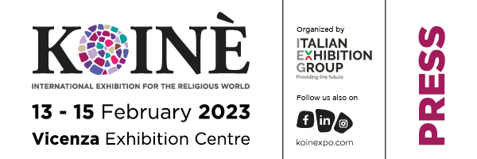

press release
(English translation)

IEG, CLOSED TODAY IN VICENZA KOINÈ:
BUYERS FROM 10 COUNTRIES AND GREAT MEDIA ATTENTION
FOR THE EVENT DEDICATED TO THE SACRED

- The return to the traditional February dates and international presences
- At the centre, the themes of religious buildings, energy sustainability and religious tourism
- Appointment in February 2025, the year of the Jubilee

Vicenza, February 15th 2023 – ﻿ The twentieth edition of the biennial Koinè - International Exhibition for the Religious World closed its doors today, with the great return of foreign buyers and visitors from 10 countries, which also obtained an excellent media response reaching 25 million contacts between newspapers , TV, radio and the web.

The international exhibition dedicated to the religious chain - organized by Italian Exhibition Group with the support of CEI and the patronage of the Diocese of Vicenza - took place at the Vicenza Expo Centre. There was much anticipation for this appointment, which after the pandemic alternations, has returned, rich in content, to the traditional dates and is already projected towards the next edition, scheduled for February 2025, again in the Berico exhibition center.

Characterized by a solid and varied exhibition offer, the event saw constant meetings between sellers and buyers from Australia, Bosnia Herzegovina, Brazil, Canada, Germany, Guatemala, Israel, Portugal, Spain and South Africa. Their participation was favored by the return of the Event to the usual February dates, as well as by Italian Exhibition Group's online platform, which made it possible to better plan meetings during the event.

Among the themes that animated Koinè 2023, religious buildings, religious tourism, ecclesiastical assets, their energy sustainability, their reuse. Spotlights focused on the Jubilee 2025 and on that of Monte Berico 2026 which will directly involve the city of Vicenza which hosts the event.

Many personalities animated the debate during the event: such as Monsignor Fabrizio Capanni, of the Dicastery of Culture and Education of the Vatican and member of the scientific committee of 'Koiné Ricerca', especially for the part dedicated to religious tourism, don Luca Franceschini, director of the National Office for ecclesiastical cultural heritage and the worship building of the Italian Episcopal Conference, and don Alberto Giardina, director of the National Liturgical Office of the Italian Episcopal Conference, for the part dedicated to the liturgy and in particular to the rediscovery of gestures such as the dedication of the altar, which fill with further contained religious ceremonies.

During the event also conferences, book presentations, moments of study. And the tribute to Ukraine - theater of war - made by the exhibitors of Koinè who donated chalices and liturgical objects at the opening of the event: His Exc. Monsignor Mieczysław Mokrzycki of the Archdiocese of Lviv, for a truly important moment of unity and solidarity.

PRESS CONTACT ITALIAN EXHIBITION GROUP
Head of media relation & corporate communication: Elisabetta Vitali; press office manager: Marco Forcellini;
international press office coordinator: Silvia Giorgi; media@iegexpo.it

This press release contains forecast elements and estimates that reflect the management’s current opinions (“forward-looking statements”), particularly regarding future management performance, realization of investments, cash flow trends and the evolution of the financial structure. For their very nature, forward-looking statements have a component of risk and uncertainty, as they depend on the occurrence of future events. The effective results may differ (even significantly) from those announced, due to numerous factors, including, only by way of example: food service market and tourist flow trends in Italy, gold and jewellery market trends, green economy market trends; the evolution of raw material prices; general macroeconomic conditions; geopolitical factors and evolutions in the legislative framework. Moreover, the information contained in this release does not claim to be complete, and has not been verified by independent third parties. Forecasts, estimates and objectives contained herein are based on the information available to the Company as at the date of this release.

