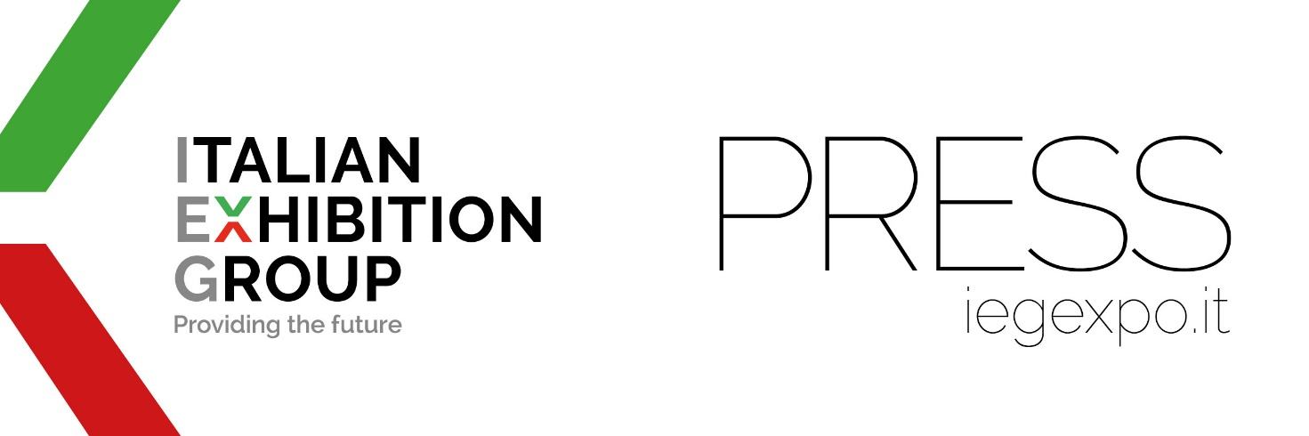

press release
(English translation)

WITH IEG IN CHINA, AT CDEPE IN CHENGDU,
THE ITALIAN CIRCULAR ECONOMY SMES

From March 30 to April 1,
the 17th edition of the Chengdu International Environmental Protection Expo

www.cdepe.com

Rimini (Italy)/Chengdu, 29 March 2023 - Chengdu International Environmental Protection Expo (CDEPE) will inaugurate its 17th edition tomorrow in China with a pavilion dedicated to Italian SMEs specialised in the field of safeguarding the environment, renewable energies, and the circular economy.
“This year, CDEPE - revealed Lorenzo Cagnoni, IEG President – is the first large-scale event in the field of environmental protection to be held in western China, since the reopening the Red Dragon’s borders after three years”.
“With 25 thousand square metres and 360 companies - commented CEO of IEG, Corrado Peraboni - CDEPE 2023 will outdo the 2019 numbers, reflecting a positive rebound of the environmental protection industry in western China, open to a technological exchange with Italy”.

THE ORGANISERS
CDEPE, one of the major Chinese trade shows in the environmental protection sector, will take place at the Chengdu Century City New International Convention and Exhibition Center until April 1, and is organised by IEG - Italian Exhibition Group (driver of Ecomondo and K.EY, headed by Alessandra Astolfi, Global Exhibition Director) and China Association of Environmental Protection Industry (CAEPI) with the support of Sichuan Environmental Protection Industry (SCEPI) and Europe China Environmental Exhibitions (ECEE).

ITALIAN TRADE AGENCY AND ITALY’S GREEN ECONOMY PAVILION: THE PROVENANCE OF THE COMPANIES
The nine companies present at CDEPE 2023 in Chengdu are SMEs providing technological solutions in diverse fields of the circular economy: water pollution control, prevention and mitigation of air pollution, environmental monitoring and solid waste treatment, energy savings and new energies, environmental services, green packaging, and certifications. From Lombardy, Air Clean, Megasystem and Sebigas Renewable Energy, from Emilia, Compopack and Hydro Italia, Labio Test from Udine, Mold from Veneto, Systea from Lazio, and Rina Consulting, a global player in environmental and technological certification. The Italian Pavilion has been created in partnership with ITA-ITALIAN TRADE AGENCY, which endorses the development of Italian enterprises on foreign markets, and by the Ministry of Foreign Affairs and International Cooperation. ITA has a network of offices in Peking, Shanghai, Guangzhou, and Hong Kong, and is set to open a fifth in Chengdu, in close collaboration with the Italian Consulate in Chongqing, in order to further develop and enhance economic and trade relations between Italy and China, particularly in the province of Sichuan and in the south-west regions of China. The b2b2g nature of the Chinese event makes it the perfect stage for Italian companies to reach a wide pool of environment tech users from both private companies and local institutions in the Sichuan province, boasting a population of over 80 million.

PRESS CONTACT ITALIAN EXHIBITION GROUP media@iegexpo.it
head of media relation & corporate communication Elisabetta Vitali; press office manager Marco Forcellini
Silvia Giorgi, international press office manager

This press release contains forecast elements and estimates that reflect the management’s current opinions (“forward-looking statements”), particularly regarding future management performance, realization of investments, cash flow trends and the evolution of the financial structure. For their very nature, forward-looking statements have a component of risk and uncertainty, as they depend on the occurrence of future events. The effective results may differ (even significantly) from those announced, due to numerous factors, including, only by way of example: food service market and tourist flow trends in Italy, gold and jewellery market trends, green economy market trends; the evolution of raw material prices; general macroeconomic conditions; geopolitical factors and evolutions in the legislative framework. Moreover, the information contained in this release does not claim to be complete, and has not been verified by independent third parties. Forecasts, estimates and objectives contained herein are based on the information available to the Company as at the date of this release.

