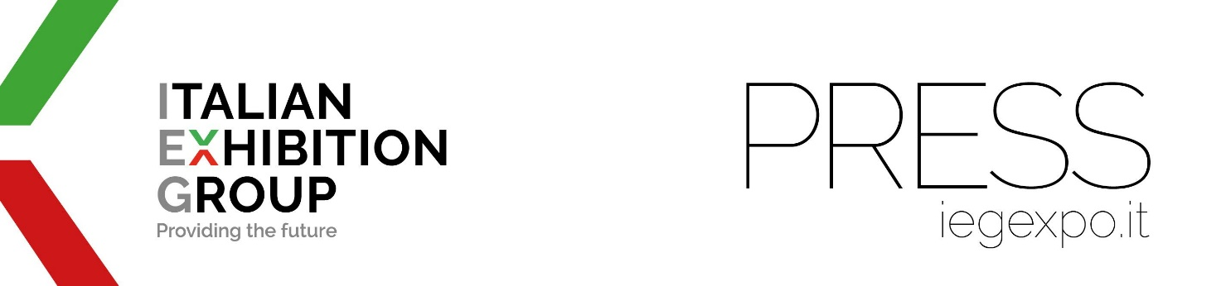

press release
(English translation)

USA: FB INTERNATIONAL IS 100% IEG

- Tommaso Cancellara, President and CEO
- Carlo Costa, CCO of IEG Group, has been nominated Chairman of the Board
- The outfitting company worked on 130 events in 2023 for a turnover of 27 million dollars

Rimini, 30 August 2024 - FB International is 100% owned by Italian Exhibition Group, which, through IEG USA, has exercised its purchase option and now holds full ownership.
The governance of the American company is also new with Tommaso Cancellara taking on the role of President & CEO. The Board of Directors on the other hand, is presided over by Chairman Carlo Costa, also CCO of the entire IEG Group.

Since 1988, FB International Inc. has been designing and outfitting stands for exhibitions and events throughout the United States and had joined the IEG Group in 2018.
“In 2023,” says Tommaso Cancellara, “FB International was involved in 130 events and its turnover amounted to 27 million dollars, acting as general contractor or appointed contractor.”
Overall, FB International employs more than 100 staff and a ‘multicultural team’ that follows the projects and speaks all languages, including Italian, in order to create exhibition projects.

The company's headquarters are in New Jersey, while an operational hub is located in Las Vegas so as to promptly cover the main US trade show venues: New York and Las Vegas.
“The locations of its offices,” explains Carlo Costa, “allow FB International to accompany its 400 clients from all over the world at their trade show and event appearances throughout the US.”
In November 2023, FB moved to new headquarters in Fairfield, again in New Jersey, where, in a modern and well-organised 11,000 square metre facility, the joinery, carpentry, painting and graphics workshops operate together with the production and assembly of the designed fittings. The headquarters in Las Vegas, Nevada, which serves the entire West Coast, has also been relocated to a new 3,500 m² modern facility.

PRESS CONTACT ITALIAN EXHIBITION GROUP | media@iegexpo.it
head of corporate communication & media relation: Elisabetta Vitali|
press office manager: Marco Forcellini, Pier Francesco Bellini | international press office coordinator: Silvia Giorgi | press office coordinator: Luca Paganin | press office specialist: Nicoletta Evangelisti, Mirko Malgieri

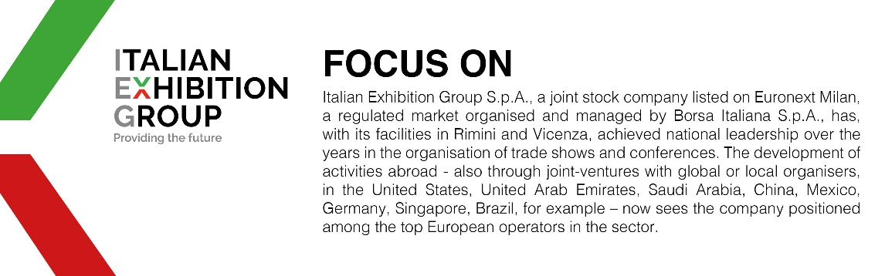

This press release contains forecast elements and estimates that reflect the management’s current opinions (“forward-looking statements”), particularly regarding future management performance, realization of investments, cash flow trends and the evolution of the financial structure. For their very nature, forward-looking statements have a component of risk and uncertainty, as they depend on the occurrence of future events. The effective results may differ (even significantly) from those announced, due to numerous factors, including, only by way of example: food service market and tourist flow trends in Italy, gold and jewellery market trends, green economy market trends; the evolution of raw material prices; general macroeconomic conditions; geopolitical factors and evolutions in the legislative framework. Moreover, the information contained in this release does not claim to be complete, and has not been verified by independent third parties. Forecasts, estimates and objectives contained herein are based on the information available to the Company as at the date of this release.

