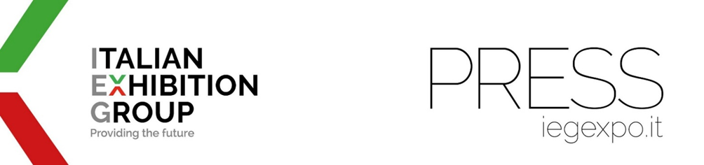
press release
VICENZA, A NEW SHOW IN ARRIVAL:
ADHESIVES BONDING & SEALANTS – ABS EUROPE 2026

- Italian Exhibition Group and A151 are launching Europe’s first trade show for the adhesive, bonding and sealant industry
- Italy is a sector leader, numerous companies located in the North East

Vicenza, 5th May 2025 – Italian Exhibition Group (IEG) and A151 announce a partnership for ADHESIVES BONDING & SEALANTS - ABS EUROPE 2026, a new event specifically for integrated technologies and solutions for the adhesive, bonding and sealant industry, scheduled to take place at Vicenza Expo Centre from 27th to 29th October 2026.
In 2024, the Italian adhesive and sealant market was worth 1.49 billion dollars. Annual growth for 2023-2033 is forecast at 5.81%.

“Adhesives Bonding & Sealants – ABS EUROPE 2026 will be Europe’s first event dedicated exclusively to this innovative and articulate industrial sector,” says IEG CEO Corrado Peraboni. “Italy is a sector leader with numerous companies located in the North East. Our Vicenza venue is therefore ideal for this event and we are delighted to enrich the Vicenza calendar with a product of certain appeal for the industry.”

“The business world that ABS EUROPE 2026 will bring together in Vicenza,” adds Marco Pinetti, Director of A151 Srl and the event, “is of fundamental importance for almost every manufacturing sector. The products and solutions on display have countless transversal uses. Consumption, which has been growing steadily for years, is consequently high and is now essential for companies in every production and application field.”

“ABS EUROPE 2026,” explains Marco Cecchini, IEG’s business development manager Italy & EU, “will be an international trade show with a focus on the sector’s development and technological innovation. Not just a B2B trade show, but also a speaking-platform that will highlight companies’ growing commitment to cutting-edge and sustainable eco-technological innovations.”

On show in Vicenza at ABS EUROPE 2026 adhesives, bonding, sealants, tapes, coatings, laminates, resins, foams and films in their various manufacturing and application forms: raw materials, materials, machinery, technologies, solutions, systems and services. The quality of end products and their performance depends on adhesives, bonding, coatings, protective films and sealants. Companies therefore pay great attention to technological developments and quality of supply. The use of increasingly high-performance adhesives has replaced screws and bolts and, more generally, fasteners in many different industrial applications.

ABS EUROPE 2026 will take place concurrently with A&T - Automation & Testing, the leading trade show for technological solutions, innovation, reliability and 4.0 - 5.0 skills, which registered more than 12,000 trade visitors at its last edition. Operators will thus be able to tour the ABS EUROPE 2026 and A&T 2026 halls, while freely participating in conferences and events organised by both shows.

FOCUS ON ITALIAN EXHIBITION GROUP
Italian Exhibition Group S.p.A., a joint stock company listed on Euronext Milan with facilities in Rimini and Vicenza, has gained a leadership position in the organisation of trade shows and congresses and developed foreign activities that have positioned it among the sector’s top operators.

FOCUS ON A151
A151 Srl, based in Cormano (MI), has been organising B2B trade shows for over 30 years and is the owner of REFRIGERA (refrigeration industry), APPLITECH (household appliance production), E-TECH EUROPE (electric vehicle production), E-CHARGE (EV charging), and TRAFFIC (traffic management), to name but a few.

PRESS CONTACT ITALIAN EXHIBITION GROUP | media@iegexpo.it
head of corporate communication & media relation: Elisabetta Vitali| press office manager: Marco Forcellini, Pier Francesco Bellini | international press office coordinator: Silvia Giorgi | press office coordinator: Luca Paganin | press office specialist: Nicoletta Evangelisti, Mirko Malgieri

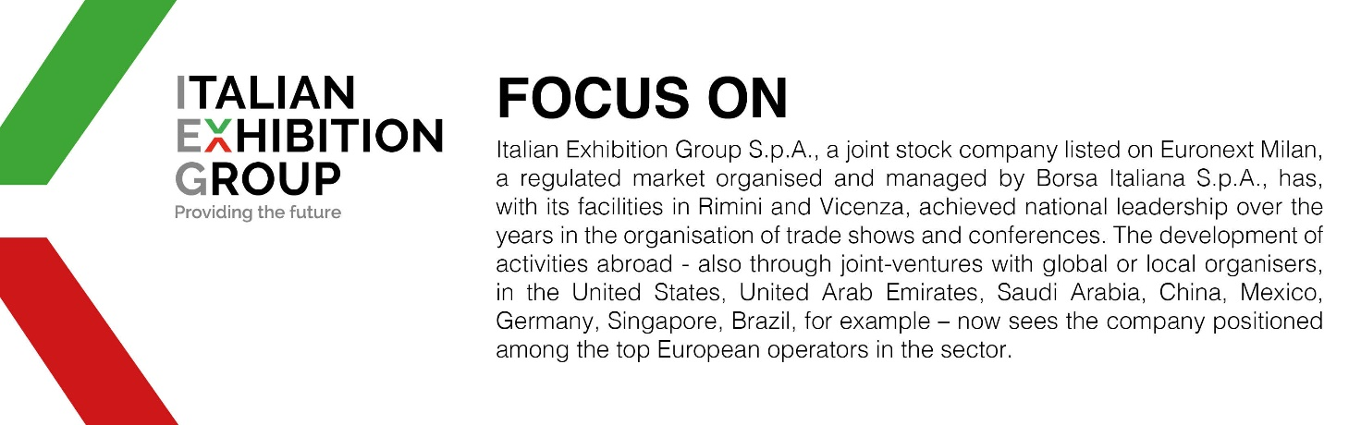

This press release contains forecast elements and estimates that reflect the management’s current opinions (“forward-looking statements”), particularly regarding future management performance, realization of investments, cash flow trends and the evolution of the financial structure. For their very nature, forward-looking statements have a component of risk and uncertainty, as they depend on the occurrence of future events. The effective results may differ (even significantly) from those announced, due to numerous factors, including, only by way of example: food service market and tourist flow trends in Italy, gold and jewellery market trends, green economy market trends; the evolution of raw material prices; general macroeconomic conditions; geopolitical factors and evolutions in the legislative framework. Moreover, the information contained in this release does not claim to be complete, and has not been verified by independent third parties. Forecasts, estimates and objectives contained herein are based on the information available to the Company as at the date of this release.

