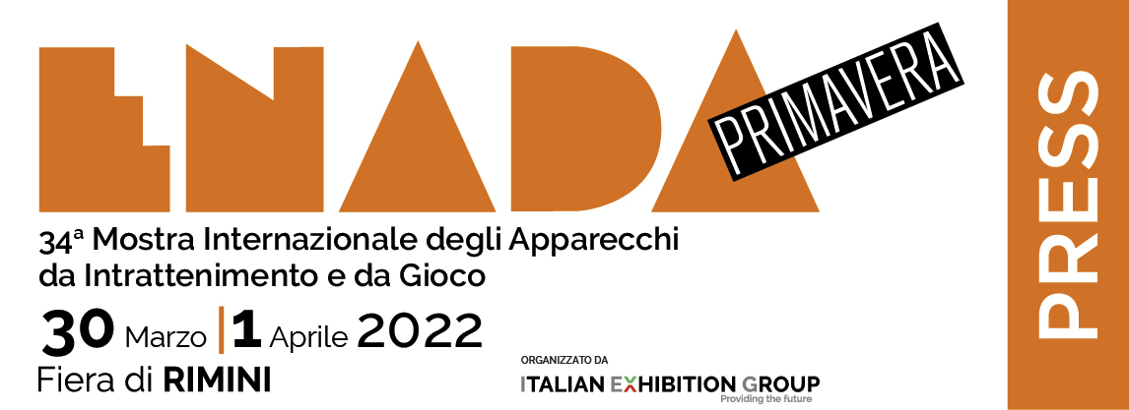
Press Release
(English translation)
ENADA CONFiRMs it’s the APPoiNTMENT not to be missed
in the GAMING world

At Rimini expo centre the 34th edition ended today of the leading show in Italy and southern Europe for professional gaming, held simultaneously with the 4th Rimini Amusement Show

- Exhibitors and the sector’s players were satisfied with a three-day event full of business and networking
- An atmosphere of confidence and greater collaboration between the sector’s associations and institutions
- The amusement sector is growing

Rimini, 1st April 2022 – After three days full of business and networking for the entire professional gaming chain, the 34th edition of Enada Spring and the 4th of Rimini Amusement Show (Rimini Expo Centre, 30th March – 1st April) ended today.

BUSINESS CONFIRMATIONS
There is a feeling of satisfaction among exhibitors and trade members who met over the last few days – at the expo’s traditional spring event - in Rimini Expo Centre’s halls just six months from last September’s appointment. In fact, Enada and Rimini Amusement, organized by Italian Exhibition Group in collaboration with SAPAR and Consorzio FEE, are among the few expos that have not missed even a single edition, although undergoing inevitable changes to their time slots during the pandemic. The approval of the public and the confirmation of business beyond expectation that characterized the two expos, held from Wednesday to today, are therefore even more significant.

COLLABORATION WITH THE INSTITUTIONS
The atmosphere of confidence and greater collaboration with the institutional world was also emphasized by the chairmen of the trade associations, who at Enada and RAS were able to discuss the market’s future, networking on the next objectives to be achieved together. This was also borne out by the conference organized by SAPAR on the issue “United beyond the reorganization: discussions between trade associations on the sector's future between reforms and new challenges”, which featured debates between the chairmen of SAPAR, ACADI (Associazione Concessionari Apparecchi da Intrattenimento), Associazione Esercenti Giochi Pubblici - Fipe and Assointrattenimento.

AMUSEMENT IS GROWING
Also worthy of note is the clear growth of the amusement sector, which also chose the expo to hold its States General, with the presentation of Roma Tre University's “Family Amusement Project”, at which participants included the chairmen of Federamusement Confesercenti, New ASGI and SAPAR.

There were also gratifying results for the Esports Business Days, organized by Italian Exhibition Group and the Italian Esports Observatory. At its second edition, the event has already grown as far as its format is concerned, adding an entire day of proceedings, and for the number of its guests and public.

The appointment with the 35th edition of Enada Spring and the 5th Rimini Amusement Show is set for March 2023, again at Rimini expo centre.

ABOUT ENADA 2022
Dates: 30th March – 1st April 2022; Organizer: Italian Exhibition Group SpA; edition: 34th; frequency: annual; info: https://www.enada.it/

ABOUT RAS 2022
Dates: 30th March – 1st April 2022; Organizers: Italian Exhibition Group, Consorzio FEE and SAPAR; edition: 4th; frequency: annual; info: https://www.riminiamusement.it/

