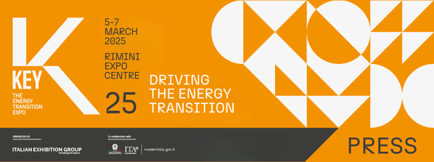

press release
(English translation)

RIMINI, KEY 2025: +20% TOTAL ATTENDANCE, + 40% FOREIGN ATTENDANCE,
RECORD SIZE AND PARTICIPATION.
IEG'S ENERGY TRANSITION EXPO IGNITES GLOBAL ENERGY

· The third stand-alone edition of Italian Exhibition Group’s event on energy transition and efficiency has come to a close at Rimini Expo Centre
· The threshold of 1,000 exhibitors, over 30% international, was exceeded. 350 hosted buyers and delegations from over 50 countries were involved
· Three intense days of business, networking and dialogue to speed up decarbonisation policies and achieve a sustainable future

Rimini, 7th March 2025 – The energy transition is gathering speed and the big, record-breaking numbers at KEY - The Energy Transition Expo, the IEG (Italian Exhibition Group) event of reference in Europe, Africa and the Mediterranean basin, which closed today at Rimini Expo Centre, are the proof.
With a +20% increase in total attendance (of which +40% from abroad) compared to 2024, over 1,000 exhibitors, of which more than 30% from abroad, 90,000 m² of floor space in 20 halls and new focuses, one on ports and the other on hydrogen, in collaboration with Hannover Fairs International GmbH (HFI), the Italian branch of Deutsche Messe AG, and no less than 400 accredited journalists from Italy and the world, the edition of KEY that just ended was the largest ever. And it was also the most international, with 350 hosted buyers and delegations from more than 50 countries attending the show thanks to the support of the Ministry of Foreign Affairs and International Cooperation (MAECI) and the Italian Trade Agency (ITA) and collaboration with leading industry associations.

For three days, KEY transformed the Expo Centre into the beating heart of energy transition and efficiency: the place where, amid innovative solutions and cutting-edge technologies, the sector’s global community began to create the future of energy.
More than 160 events, conferences and workshops with the participation of experts, academics, researchers and representatives from the world of associations and companies, offered an opportunity for discussion and in-depth analysis of the energy market’s every aspect, innovation and development.

Inaugurated on Wednesday 5th March by Minister Gilberto Pichetto Fratin, KEY25 provided a unique opportunity for sector companies and professionals to learn about present and future solutions to guarantee energy security, control energy costs, and maintain the industrial fabric’s competitiveness. Moreover, it favoured meetings and dialogue with the institutions to promote efficiency as the best way forward to meet the global challenge of decarbonisation. Also in attendance, Michele De Pascale, President of the Emilia-Romagna Region.

With the Innovation District and the second edition of the “Lorenzo Cagnoni” Award, KEY25 consolidated its support for innovation and, with the Green Jobs & Skills initiative, even extended it to the new green and sustainable skills that are still very much lacking in companies, but which need to be increasingly invested in to achieve the energy transition.
KEY CHOICE - Unlock the future of PPAs
The second edition of KEY CHOICE - Unlock the future of PPAs, KEY - The Energy Transition Expo’s B2B event, addressed the topic of energy costs and PPAs as an innovative financial solution for cost control and included a focus on the new Data Centres, indispensable for technological development. Organised by IEG in cooperation with Elemens and with the support of SolarPlaza, the event took place on Tuesday 4th March at Rimini’s Palacongressi Conference Centre to foster meetings between energy suppliers and energy-intensive companies with the aim of facilitating the drawing up of PPA contracts.

KEY will be back at Rimini Expo Centre from 4th to 6th March 2026.

ABOUT KEY 2025
Event: International trade show; Organization: Italian Exhibition Group S.p.A.; Frequency: annual; Edition: 3rd; Dates: 5-7 March 2025; mail keyenergy@iegexpo.it; Website: http://www.key-expo.com; Facebook: https://www.facebook.com/keyexpo/; Instagram: https://www.instagram.com/key_expo/; LinkedIn: https://www.linkedin.com/company/keyenergy/

PRESS CONTACT KEY - ITALIAN EXHIBITION GROUP
head of media & corporate communication: Elisabetta Vitali; press office manager: Marco Forcellini, Pier Francesco Bellini; international press office coordinator: Silvia Giorgi; press office coordinator: Luca Paganin; press office specialists: Nicoletta Evangelisti, Mirko Malgieri; media@iegexpo.it

MEDIA AGENCY: Smartitaly Communications
Sara Scatena, s.scatena@smartitaly.it, mob. +39 338 7836985; Arianna Geli, a.geli@smartitaly.it, mob. +39 347 0917903

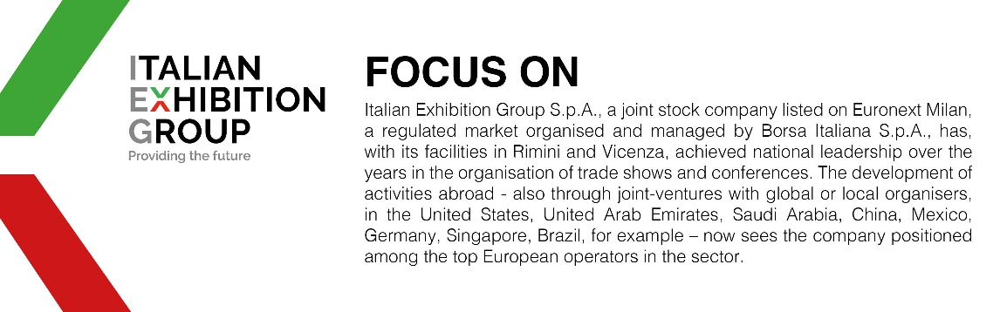

This press release contains forecast elements and estimates that reflect the management’s current opinions (“forward-looking statements”), particularly regarding future management performance, realization of investments, cash flow trends and the evolution of the financial structure. For their very nature, forward-looking statements have a component of risk and uncertainty, as they depend on the occurrence of future events. The effective results may differ (even significantly) from those announced, due to numerous factors, including, only by way of example: food service market and tourist flow trends in Italy, gold and jewellery market trends, green economy market trends; the evolution of raw material prices; general macroeconomic conditions; geopolitical factors and evolutions in the legislative framework. Moreover, the information contained in this release does not claim to be complete, and has not been verified by independent third parties. Forecasts, estimates and objectives contained herein are based on the information available to the Company as at the date of this release.

