Final Press Release

IEG, TTG TRAVEL EXPERIENCE AND INOUT THE CONTRACT COMMUNITY
+19% INDUSTRY PROFESSIONALS PRESENT. THE MARKET SAYS YES TO TRAVEL

- Above and beyond 2019 pre-pandemic numbers

- The Italian Exhibition Group tourism marketplace in constant growth, with the 60th edition of TTG

- The market enthusiastic about the debut of InOut, IEG’s new format for the contract community

- Rimini hosts 2,700 exhibiting brands, thousands of foreign buyers from 62 countries with support from the Italian Trade Agency, the US at the fore with 15% visits, 55 foreign destinations

ttgexpo.it | inoutexpo.it

Rimini, 13 October 2023 – Travel, transport, hospitality, supplies, furnishings and surfaces, the design of outdoor and green spaces: with +19% of professional visitors compared to 2022, TTG and InOut, at their 60th edition and debut respectively, wrapped up today at Rimini Fair, registering a constant positive trend in attendance of the international and Italian tourist market. Attendance was up even on 2019. TTG Travel Experience and InOut - The Contract Community of Italian Exhibition Group have proved themselves to be the most important b2b events in Italy for the international tourism industry, with 2,700 exhibiting brands. An opinion also shared by Minister of Tourism, Daniela Santanchè who last Wednesday participated in the inaugural ceremony of the two trade fairs in Rimini. Media visibility was extraordinary with over 270 million gross contacts reached.

INOUT'S DEBUT WARMLY WELCOMED BY THE CONTRACT COMMUNITY
The legacy and future of the long-standing SIA Hospitality Design and SUN Beach&Outdoor Style events are now complete with the eagerly awaited newcomer of 2023 - InOut - the new format designed by IEG and dedicated to the contract community which also includes Superfaces and the new Greenscape for the design of both indoor and outdoor green spaces in the hospitality world. They were joined by the b2b offer, featuring the swimming pool and wellness industry with the Poolwide pavilion, directed by Assopiscine, which also organized discussion panels and perspectives for an industry that boasts 2,300 Italian companies with a total of more than 15 thousand employees, and which in the last ten years has recorded an average growth of more than 5%, jumping to +13% in the last two years.

TTG TRAVEL EXPERIENCE, A THOUSAND BUYERS FOR THE BEAUTY OF ITALY
A thousand foreign buyers from 62 countries attended the fair over the three days, 58% coming from Europe and 42% from the rest of the world, by virtue of the partnership with the Italian trade Agency, in particular for the new InOut format. Coming mostly from the USA, UK, Germany, Spain, France and Switzerland, they confirmed Italy, with all its Regions present at the fair, as one of the most desired destinations by travellers
from all over the world, making Rimini the attention grabber for the incoming sector.

THE WORLD IN RIMINI: 55 FOREIGN DESTINATIONS
TTG brought 55 international destinations to Rimini: from the return of Turkey, to a greater presence from Portugal and Egypt: important recognition of the event’s strategic role. A new feature this year was the reappearance of China on the Rimini marketplace to reinvent its tourism offer. The Kingdom of Jordan, on the other hand, was TTG's country partner for the second time in a row.

LUXURY SEGMENT AND MEDITERRANEAN MARKET: A GOOD FIRST
TTG Luxury Event and TTG Med, a good first. Driven by international buyers, regulars to the Rimini marketplace, IEG created a b2b event to purchase tourist products not only in Italian destinations, but foreign-to-foreign in Mediterranean destinations, with very positive feedback from the operators. Furthermore, with the event dedicated to the luxury segment, TTG was the ideal showcase for Italian excellence in markets ranging from the United States to India, passing through France and Argentina.

THE OPENING CEREMONY, MINISTER FOR TOURISM SANTANCHÈ: TTG THE MOST IMPORTANT TOURISM FAIR IN ITALY
TTG and InOut brought to both the stakeholders of the two trade shows and to the industry players a clear message from public institutions and the government on the subject of state concessions and the centrality of tourism supply chains, in a statement from the new president of IEG, Maurizio Ermeti: «Tourism is the perfect industry for our country, because it redistributes wealth and value among medium-small enterprises».
The ceremony was attended by the vice president of the Senate, Gian Marco Centinaio, the undersecretary for Culture, Vittorio Sgarbi, the president of Federalberghi, Bernabò Bocca, the mayor of Rimini, Jamil Sadegholvaad, Andrea Corsini, councillor for Tourism of the Emilia-Romagna Region, Ivana Jelinic, President of the Italian Tourist Board, and Luigi Cabrini, president of Global Sustainable Tourism Council.

TRAVELING IN THE TIME OF UTOPIA: TOURISM RETHINKS ITSELF
TTG and InOut chose UTΦPIA as their main theme. LIVE. BELIEVE, to interpret, develop and amplify the calls for renewal permeating the tourism industry, in line with travellers’ new values. No longer a simple space for escape, tourism is preparing to welcome the challenges imposed by contemporary sentiment, with a marked attention to sustainability, in the broadest possible sense, all still to be defined and imagined, yet very much high-priority. The theme was explored in most of the events scheduled over the three days, with specific spotlights on travel, recovering our relationship with nature - from the outdoors to furnishings- and green spaces. IEG brought together the professional community offering a cross section of over 200 events with more than 250 speakers hosted in the nine Arenas: from the use of digital technologies and the metaverse to space travel, to Vision +24, to learn about the new languages of the consumer market.

EVENT STAKEHOLDERS
Alongside the most representative trade associations, as well as members from Federalberghi and all the industries represented by Confcommercio, ASTOI, FTO, FAITA Federcamping, SIB, Fiavet, Assoviaggi and CNA, Assopiscine, the National Tourist Board, all the Regions, the world of research with ISNART, Milan Polytechnic and the National Council of Research, ISMED, CISET, Legambiente, ISNART and Unioncamere.

IEG looks forward to seeing the entire Italian and international tourism industry at the next edition, from 9-11 October 2024.

ABOUT: TTG TRAVEL EXPERIENCE Event: international trade show; organizer: Italian Exhibition Group SpA; recurrence: annual; edition: 60th; open to: reserved exclusively for trade professionals; website: www.ttgexpo.it - #ttgexpo

ABOUT: INOUT, THE CONTRACT COMMUNITY Event: international trade fair; organizer: Italian Exhibition Group SpA; recurrence: annual; edition: 1st edition of INOUT combining SIA, SUN, SUPERFACES, GREENSCAPE; open to: reserved exclusively for trade professionals; website: www.inoutexpo.it #inoutexpo

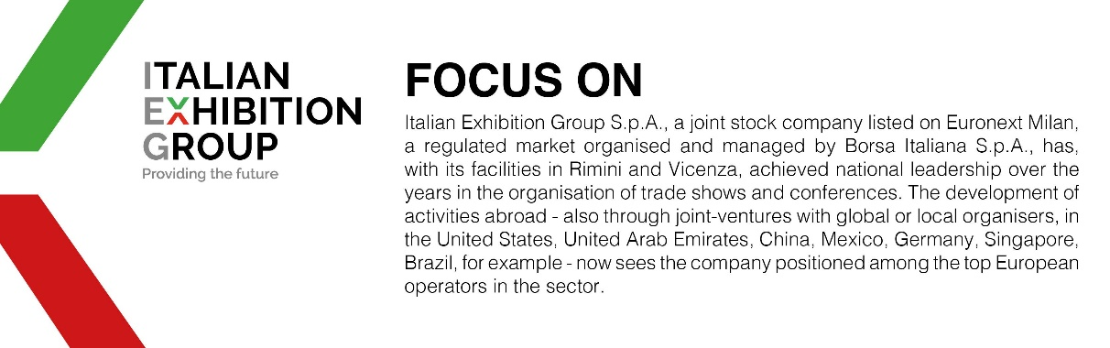

ITALIAN EXHIBITION GROUP PRESS CONTACTS
Head of media relations & corporate communication: Elisabetta Vitali; press office manager: Marco Forcellini;
international press office coordinator: Silvia Giorgi; media@iegexpo.it

MEDIA AGENCY TTG Travel Experience 2023: MY PR Lab
Filippo Nani, +39 0444.512550, filippo.nani@myprlab.it; Francesca Magnanini, +39 338 6910347, francesca.magnanini@myprlab.it; Enrico Bellinelli, +39 392 748 0967, enrico.bellinelli@myprlab.it

This press release contains forecast elements and estimates that reflect the management’s current opinions (“forward-looking statements”), particularly regarding future management performance, realization of investments, cash flow trends and the evolution of the financial structure. For their very nature, forward-looking statements have a component of risk and uncertainty, as they depend on the occurrence of future events. The effective results may differ (even significantly) from those announced, due to numerous factors, including, only by way of example: food service market and tourist flow trends in Italy, gold and jewellery market trends, green economy market trends; the evolution of raw material prices; general macroeconomic conditions; geopolitical factors and evolutions in the legislative framework. Moreover, the information contained in this release does not claim to be complete, and has not been verified by independent third parties. Forecasts, estimates and objectives contained herein are based on the information available to the Company as at the date of this release.

